Chapter 13

Study and Empirical Analysis of Sentiment
Analysis Approaches
Monish Gupta¹, Sumedh Hambarde², Devika Verma³, Vivek Deshpande⁴ and Rakesh Ranjan⁵
^{1,2,3,4} Vishwakarma Institute of Information Technology, India
⁵ Charles W Davidson College of Engineering, San Hoje State University, USA
{¹monish.17u611, ^{2,}sumedh.17u570,³devika.verma, ⁴vivek.deshpande}@viit.ac.in ⁵ rakesh.ranjan@sjsu.edu
Abstract. Sentiment analysis is useful tool for social media and customer analysis allowing us to get summary of the views of large public behind a topic. This work conducts an empirical survey by implementing various state of the art sentiment analysis techniques; cover the working, advantages and limitations of each of these methods and conduct an experiment to find out which of these methods is best suited for sentiment analysis in today’s scenario. Experimentation highlights that the lexicon-based methods resulted into less accuracy while machine learning algorithms like Support Vector Machines (SVM), Multinomial Logistic Regression (MLR) and Deep Learning based algorithms like Convolutional Neural Network (CNN) and Bi-Directional Recursive Neural Network (RNN) show improved performances.

Keywords: Sentiment Analysis · Opinion Mining · Machine Learning ·
Lexicon Based Approach · Deep Learning

Introduction
“Data is the new oil”, in the 21st century. But just like oil is an immensely valuable asset but of no value when unrefined, the huge amount of data when processed can yield valuable information which can help in various fields and applications. Considering the huge size of the data being generated every day, it is not possible to process all this data manually. Various techniques have been employed to extract useful information from the data, one of them being sentiment analysis or opinion mining. Sentiment analysis is the process of finding the sentiment, mostly positive, negative, neutral, given a portion of text. Apart from these categories, there are other categories in which the text can be classified into, e.g., happy, angry, sad, surprised, enthusiastic [16].
With the popularisation of Web 2.0, there has been an explosion in the amount of user-generated data on the internet. Sentiment analysis has been used in applications in a variety of fields. People express their opinions on popular social media sites as well as product review sites. Along with this, there are other sources of data like news articles related to all kinds of events like politics, entertainment, sports, finance, etc. Businesses can analyse the product reviews of their products posted online by customers and make suitable changes [11]. Analysis of product reviews posted on online shopping sites can help identify products which a customer is more likely to buy, boosting profits for the company, as well as increasing customer ease [31]. Sentiment analysis of reviews on travel and tourism websites [19] can help in recommending better hotels and destinations to tourists and boost the tourism industry, while sentiment analysis of news articles [26] can help in creation of customized news feeds sent to users. Movie review analysis has also been done to increase quality of movie recommendations [23,20]. Sentiment analysis has also been done to improve accuracy of predictions, like election-results [27] and movement in stock-prices based on financial news [25,12]. In this work, we review and implement different approaches for sentiment analysis; cover the working, advantages and limitations of each of these methods and conduct an experiment to find out which of these methods is best suited for sentiment analysis in today’s scenario. Paper is organized as follows: Section 2 covers the related work summarising popular sentiment analysis techniques. This is followed by experiment design in section 3. We discuss results in section 4 followed by conclusion and future work in the last sections.

Literature Survey
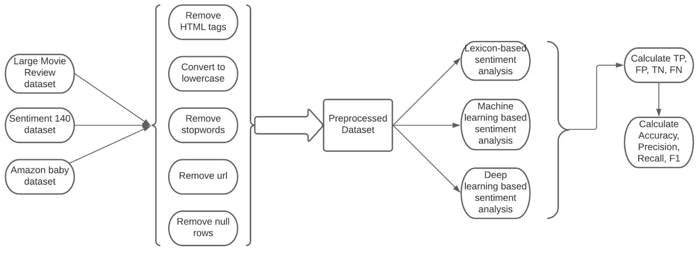
Fig.1. Sentiment Analysis Architecture
Sentiment analysis process usually includes three common steps as shown in Figure 1. The first step is pre-processing of the dataset, which involves removing stop words, null rows, html tags, url and converting text to lowercase. Once the data is pre-processed, and features are extracted sentiment classification is performed on it. Finally, the results of the analysis are evaluated by using confusion matrix to calculate precision, recall, accuracy and F1score.
The various methods available for sentiment classification can generally be divided into lexicon-based methods, machine-learning based methods and deep-learning based methods, with each having its own advantages and drawbacks.

Lexicon-based methods
Lexicon-based methods consist of creating a lexicon of sentiment words, and the sentiment scores associated with them. Sentiment words are those positive or negative words which are deemed to be important in calculating sentiment. [9] proposed an approach to predict sentiment by counting the number of positive and negative words in a sentence; this method can be broadly described as “lexicon-based method”. Popular lexicons are SentiWordnet, Liu and Hu opinion lexicon, SentiWords [30]. SentiWordnet assigns to each sentiment word a positivity score, a negativity score and an objectivity score. SentiWords assigns to the words a score between -1 and 1 based on the positivity and the negativity.
The principal advantage of the lexicon-based methods is that as they are unsupervised methods, they have no need for a training phase or a labelled dataset. But the disadvantage being that the contextual information is ignored, e.g., in the sentence “The product is cheap and easy-to-use, but it stopped working within 1 month”, there are more positive words (cheap, easy-to-use) than negative words (stopped), so probability of it being classified as positive is higher, though from the context we can see that it is a negative review.
Certain work has been done to overcome this disadvantage of lexicon-based methods by combining it with other deep-learning based methods. [31] proposes a model for sentiment analysis by combining lexicon-based methods and deep-learning, where the lexicon is used to enhance sentiment features and deep learning is used to extract the features and perform sentiment analysis. Neural networks and SentiWordnet lexicon were combined to perform sentiment analysis by [23]. 81 major non-English language lexicons were gathered by [5].

Machine-learning based methods
Several research highlight the recent shift towards statistical approach for sentiment analysis, relying on sufficiently large datasets for training the machine learning model in a supervised manner. A hybrid sentiment classification model of Support Vector Machine (SVM) and adaboosted decision tree was proposed in [21]. It consists of first sending the preprocessed data as input to the SVM and adaboosted decision tree and then the outputs of these two models is passed as an input to the decision tree. The Naïve bayes and SVM machine learning models were trained on amazon dataset which contains reviews of various products like Camera, Laptops, Mobile phones, tablets, TVs, video surveillance and [11] reported an accuracy of 98.17% for Naïve bayes and 93.54% using SVM for sentiment analysis of Camera Reviews. The authors of [8] compared three sentiment analysis lexicon methods named SentiWordnet, TextBlob and W-WSD along with the machine learning techniques, Naïve bayes and SVM. A comparative study of five types of machine learning classifiers namely multinomial Naïve bayes, Bernoulli Naïve bayes, SVM, Maximum Entropy and Decision Trees was carried out in [20]. [7] show a comparative study of Naïve Bayes, SVM, Random Forest and Maximum Entropy on the google reviews dataset. [17] proposed the use of Naïve bayes method for sentiment analysis and to tag them as positive or negative whereas [24] highlight SVM gives high accuracy compared to Naïve bayes and maximum entropy methods.

Deep-Learning Based Methods
Studies highlight that with smaller dataset although machine learning methods are preferable, provided availability of sufficiently large dataset, deep learning algorithms have outperformed other approaches to sentiment analysis. [28] found out that multilayer perceptron provides the best results among Multilayer perceptron, SVM and random forests when implemented for sentiment analysis. Bidirectional long short-term memory units to extract aspect from given headline or microblog was proposed in [12] and the [31] proposed a new sentiment analysis model-SLCABG, which is based on the sentiment lexicon and combines the attention-based Bidirectional Gated Recurrent Unit (BiGRU) with the Convolutional Neural Networks (CNN). Bi-LSTM model was proposed on the Militarylife board on PTT website data in [14] along with the support of a self-developed military sentiment dictionary. [25] proposed the combination of deep learning methodologies of recurrent neural network with long short-term memory units to train the Thompson Reuters News Archive Data. [1] highlights latest studies regarding the implementation of various deep learning models such as deep neural networks, convolutional neural networks etc. for solving different problems of sentiment analysis and [10] proposes the use of SentiCNN model.

Datasets
Datasets used for sentiment analysis differ based on the field of application. Most of the research involves using publicly available data from online product review websites. The Movie Review Dataset issued by Stanford consisting of 50,000 IMDb movie reviews which are labelled positive or negative [23]. Work done by [19] consolidates reviews from popular hotel review website TripAdvisor. [31] uses product reviews from famous Chinese shopping website dangdang.com, while lot of studies make use Amazon reviews dataset, BBC news dataset [26], tweets from Twitter [21,8,32] for sentiment-analysis. The benefits of using a twitter dataset are more information and sentiments expressed in lesser words, availability of a vast dataset, and possibility of real-time analysis.

Experiment Methodology
For empirical analysis of different sentiment analysis approaches, we setup an experiment over three different datasets over a variety of methods described in Figure 2.
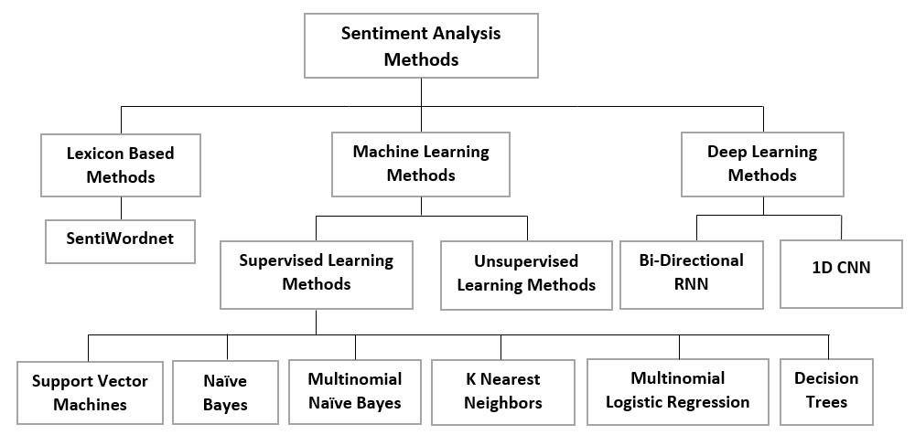
Fig.2. Sentiment Classification Methods Used for Experimentation
Considering the wide variety of applications of sentiment analysis, we selected following datasets to be used in the experiment;
- Large Movie Review Dataset [15]: This is a dataset provided by the Stanford University and consists of 25,000 movie reviews for training and 25,000 movie reviews for testing. It consists of two classes (positive = 1 and negative = 0). Out of the 25,000 reviews each provided for training and testing, 12,500 reviews are positive and the remaining 12,500 reviews are negative.
- Sentiment 140 Dataset [2]: This dataset consists of 1.6 million tweets extracted from twitter and consists of two classes (0 = negative and 4 = positive)
- Amazon Baby Dataset: This dataset consists of reviews from amazon and has 3 columns (name, review and rating). Here name field contains the subject of the reviews, review field contains the text data and ratings field consists of numbers from 1 to 5 where 1 means worst and 5 means the best.

Pre-processing
To extract the features from text which are not explicitly available like in structured data, we need to clean data to remove unwanted characters and perform pre-processing on all the corpus.

Pre-processing on Large Movie Reviews Dataset
- Removing HTML tags: HTML tags contained in reviews field are removed.
- Lowercase: Converted the reviews to lower case.
- Stopwords: Removed the stopwords contained in reviews.

Pre-processing on Sentiment140 Dataset
- Trimming the dataset: Trimmed the dataset to contain 12,500 positive reviews and 12,500 negative reviews.
- Removing HTML decoding: Removing HTML decoding like &amp, &quot etc.
- Removing @username: Removed the username contained in the tweets.
- Removing URL links: Removed URL links contained in the tweets.
- Hashtags: Hashtags might contain important information which is necessary to understand the sentiment so we just removed the hashtag symbol and kept the text under it in our reviews.
- Lowercase: Converted the tweets to lowercase.
- Stopwords: Removed the stopwords contained in the tweets.

Pre-processing on amazon-baby Dataset
- Remove null rows: Remove the rows containing empty fields.
- Add sentiment field based on ratings: We assigned the review a negative sentiment if it has rating 1 or 2 and assigned the review a positive sentiment if it has rating 4 or 5. We dropped the reviews containing the rating as 3 since we only wanted two sentiment classes, positive and negative.
- Trimming the dataset: We trimmed the dataset to contain 12,500 positive reviews and 12,500 negative reviews.
- Combined the name and review field: Since both the columns are important in sentiment classification, we combined them into one column to pass it to our model.
- Lowercase: The reviews are converted to lowercase.
- Stopwords: The stopwords are removed from the reviews.
Most of the pre-processing steps were implemented using source python library re [29] and NLTK [4]. Additionally, we even performed vectorization and train test split on all the 3 datasets. In case of machine learning for vectorization we used the tf-idf vectorizer and the values of their attributes are as follows. (max_features = 5000, min_df = 5 and max_ df = 0.7). In case of deep learning, we first padded the reviews and then for vectorization we used word embeddings provided by Keras [6]. Then we split the dataset and allotted 70% of the dataset for training and 30% for testing.

Methods
Lexicon-based In this method, we used the SentiWordnet lexicon [3], which is the most commonly used lexicon for lexicon-based sentiment analysis. It assigns to each synset of the Wordnet lexicon positivity, negativity and objectivity scores. If the positivity score is greater than the negativity score, then the predicted sentiment is “positive” and vice versa.
The labelled and predicted sentiments are then compared to calculate accuracy, precision, recall and f1-score for the method.

Machine Learning We train the sentiment classification model using six different machine learning algorithms i.e., SVM, Naïve Bayes, Decision Trees, Multinomial Naïve bayes, KNN and Multinomial Logistic Regression. All the six models have been implemented using the open-source python sklearn library [18]. The attributes of each of these methods are described below.
- SVM: Regularization parameter is set to 1, kernel = linear and gamma = ‘auto’.
- Naïve Bayes: Default attributes provided by sklearn.
- Multinomial Logistic Regression: Attribute multi class = ‘multinomial’ and solver = ‘newton-cg’.
- Multinomial Naïve Bayes: Default attributes provided by sklearn.
- KNN: Attribute n_neighbors = 7.
- Decision Trees: Default attributes provided by sklearn.
Deep Learning For deep learning we implement Bi-directional Recurrent Neural Network [22] and 1D Convolutional Neural Network [13]. Both of these models have been implemented by using the Keras library.

Evaluation metrics
The performances of the different sentiment classification techniques are measured using following metrics:
True Positive (TP): Positive text classified as positive.
False Positive (FP): Negative text classified as positive.
True Negative (TN): Negative text classified as negative.
False Negative (FN): Positive text classified as Negative.
$Accuracy= \frac{TP + TN}{TP + TN + FP + FN}$ * 100
Precision: The ratio of true positives to the total reviews classified as positive.
$Precision= \frac{TP}{TP + FP}$ * 100
Recall: The ratio of True Positives to total actual positives.
$Recall= \frac{TP}{TP + FN}$ * 100
F1: The weighted average of precision and recall.
$F1= \frac{2* precision*recall}{precision+recall}$ * 100

Results

Results of Lexicon Based Methods
The model evaluation metrics used for lexicon-based models are accuracy, precision, recall and f-score. The results of lexicon-based models are shown in table 1. The average F-score achieved using lexicon-based methods is 62.33%.
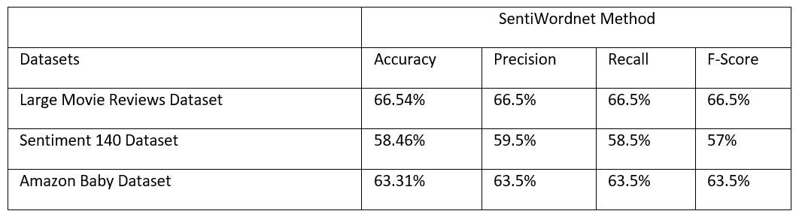
Table 1. Results of SentiWordnet

Results of Machine Learning Based Methods
The model evaluation metrics used for machine learning models are accuracy, precision, recall and f-score. The results of machine learning models are shown in tables 2 to 7. The average F1 score using SVM is 84%, using Naïve Bayes is 74.50%, using Multinomial Naïve Bayes is 82%, using Decision Trees is 71%, using Multinomial Logistic Regression is 84.33% and using K Nearest Neighbors is 71.16%. The result highlight that we achieved the best performance using the Multinomial Logistic Regression algorithm.
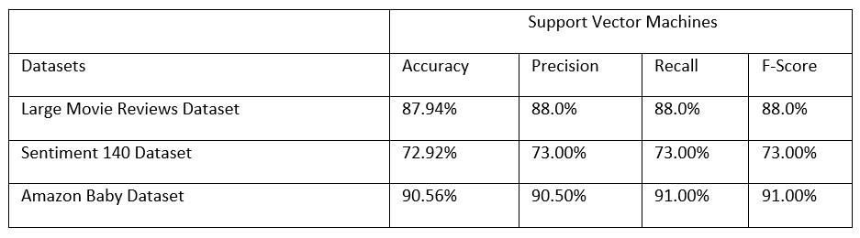
Table 2. Results of Support Vector Machines

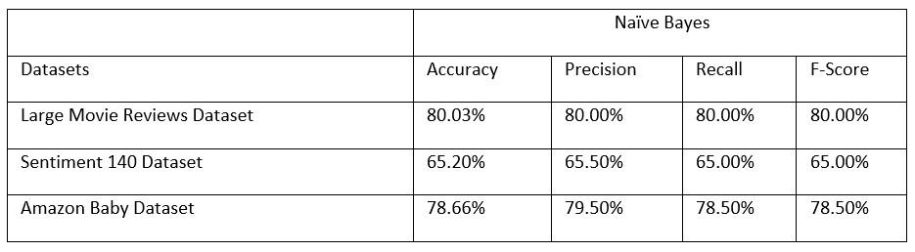
Table 3. Results of Naïve Bayes
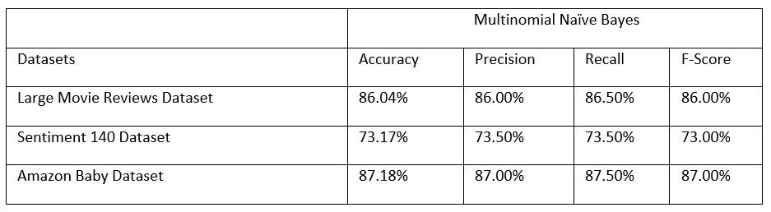
Table 4. Results of Multinomial Naïve Bayes
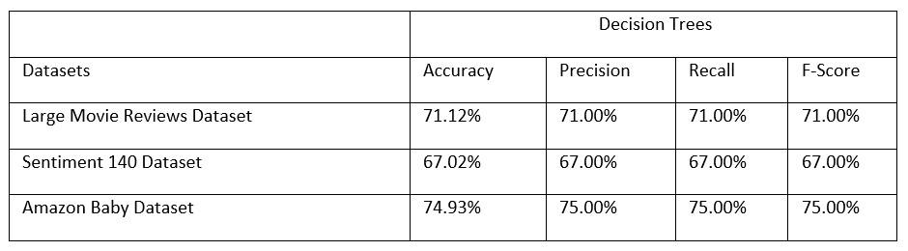
Table 5. Results of Decision Trees
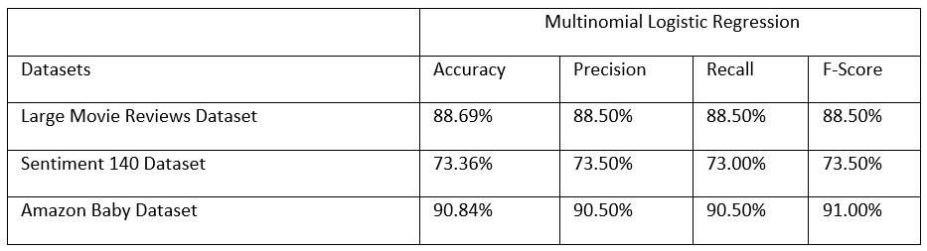
Table 6. Results of Multinomial Logistic Regression
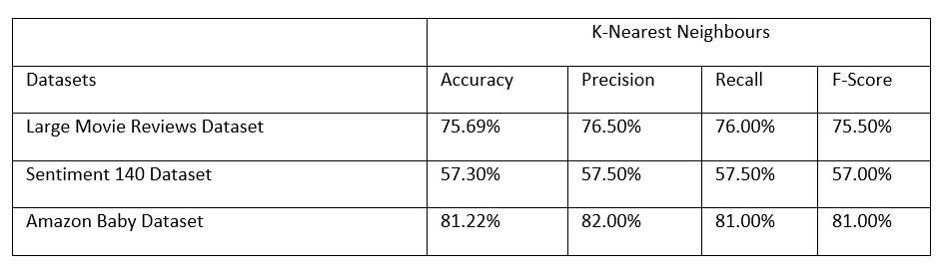
Table 7. Results of K Nearest Neighbors

Results of Deep Learning Based Methods
We have used accuracy as an evaluation metric for deep learning models. The results of deep learning models are shown in the table 8. The average accuracy for Bi-directional Recurrent Neural Network is 83.03% and the average accuracy for 1D Convolutional Neural Network is 80.32%. The results of deep learning methods highlight that Bi-directional Recurrent Neural Network provides slightly better results than 1D Convolutional Networks.

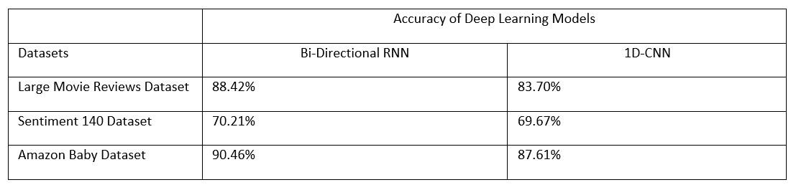
Table 8. Results of Deep Learning Methods
The results obtained from the above experiment show that lexicon-based method does not give the best results mostly due to the inability of the lexicon-based method to integrate the contextual information into the process; treating the sentence as a bag-of-words and ignoring the word order of the sentences; apart from that negation handling is a feature that needs to be dealt with to improve the accuracy of the model. Lexicon-based method can be integrated with deep learning methods to best handle these problems. Amongst machine learning algorithms, Support Vector Machines and Multinomial Logistic Regression gave higher results compared to other algorithms we experimented with. For Deep Learning Approach, both algorithms have shown similar performances with the Bi-directional RNN giving slightly better results than 1D convets.

Conclusion
This paper compares the best models under the three main types of sentiment analysis methods which are lexicon-based, machine learning and deep learning methods. It was found that machine learning and deep learning methods provide better results than the lexicon-based methods, provided the availability of relevant dataset. Through the experiment conducted, we identify that SVM and Multinomial logistic regression provided better results than the other machine learning methods mentioned. For deep learning approach, both algorithms show similar performances with bi-directional RNN giving slightly better results than 1D-convets.

Future Work
Apart from the huge amount of textual data, more and more audio-video data is being produced every day with the rise of social media companies like Instagram, Facebook, etc. Most of the current research is focused on sentiment analysis of textual data; however, work needs to be furthered in the fields of image sentiment analysis and video sentiment analysis.
Sarcasm detection is another challenge of sentiment analysis in which further work needs to be done; as people convey negative emotions using positive words, there is high probability of the review being misclassified as positive instead of negative.
While there has been a considerable amount of research done in sentiment analysis in non-English languages, the major challenges which face us are the lack of availability of quality lexicons for these languages, and the usage of mixed language. Further work can be done to introduce a standard cross-lingual approach framework and develop quality lexicons for other languages.
Most of the work done so far focuses on classifying the text into positive or negative. But for specific projects, a more detailed categorization of the text may be needed, e.g., angry, disappointed, happy, enthusiastic, etc. Work needs to be done to make the classifications more detailed and accurate.

References
- Ain, Q.T., Ali, M., Riaz, A., Noureen, A., Kamran, M., Hayat, B., Rehman, A.: Sentiment analysis using deep learning techniques: A review. International Journal of Advanced Computer Science and Applications 8(6) (2017).
https://doi.org/10.14569/IJACSA.2017.080657, http://dx.doi.org/10.14569/IJACSA.2017.080657
- Alec Go, R.B., Huang, L.: Twitter sentiment classification using distant supervision. CS224N Project Report, Stanford, 1 (2009)
- Baccianella, S., Esuli, A., Sebastiani, F.: Sentiwordnet 3.0: An enhanced lexical resource for sentiment analysis and opinion mining. In: Calzolari, N., Choukri, K., Maegaard, B., Mariani, J., Odijk, J., Piperidis, S., Rosner, M., Tapias, D. (eds.) LREC. European Language Resources Association (2010), http://nmis.isti.cnr.it/sebastiani/Publications/LREC10.pdf
- Bird, S., Klein, E., Loper, E.: Natural language processing with Python: analyzing text with the natural language toolkit.” O’Reilly Media, Inc.” (2009)
- Chen, Y., Skiena, S.: Building sentiment lexicons for all major languages. In: ACL (2014)
- Chollet, F., et al.: Keras. https://keras.io (2015)
- Gomathi, D.S.: Sentiment analysis of google reviews of a college (2019)
- Hasan, A., Moin, S., Karim, A., Band, S.: Machine learning-based sentimental analysis for twitter accounts. Mathematical and Computational Applications 23, 11 (02 2018). https://doi.org/10.3390/mca23010011
- Hu, M., Liu, B.: Mining and summarizing customer reviews. In: Proceedings of the Tenth ACM SIGKDD International Conference on Knowledge Discovery and Data Mining. p. 168–177. KDD ’04, Association for Computing Machinery, New York, NY, USA (2004).
https://doi.org/10.1145/1014052.1014073, https://doi.org/10.1145/1014052.1014073
- Huang, M., Xie, H., Rao, Y., Liu, Y., Poon, L.K.M., Wang, F.L.: Lexicon-based sentiment convolutional neural networks for online review 12 Gupta et al. analysis. IEEE Transactions on Affective Computing pp. 1–1 (2020). https://doi.org/10.1109/TAFFC.2020.2997769
- Jagdale, R., Shirsat, V., Deshmukh, S.: Sentiment Analysis on Product Reviews Using Machine Learning Techniques: Proceeding of CISC 2017, pp. 639–647 (01 2019). https://doi.org/10.1007/978-981-13-0617-4 61
- Jangid, H., Singhal, S., Shah, R.R., Zimmermann, R.: Aspect-based financial sentiment analysis using deep learning. pp. 1961–1966 (04 2018).
https://doi.org/10.1145/3184558.3191827
- Kiranyaz, S., Avci, O., Abdeljaber, O., Ince, T., Gabbouj, M., Inman, D.J.: 1d convolutional neural networks and applications: A survey. Mechanical Systems and Signal Processing 151, 107398 (2021).
https://doi.org/https://doi.org/10.1016/j.ymssp.2020.107398,
https://www.sciencedirect.com/science/article/pii/S0888327020307846
- Liang-Chu Chen, C.M.L., Chen, M.Y.: Exploration of social media for sentiment analysis using deep learning. Soft Computing 24, 8187–8197 (2020). https://doi.org/10.1007/s00500-019-04402-8
- Maas, A.L., Daly, R.E., Pham, P.T., Huang, D., Ng, A.Y., Potts, C.: Learning word vectors for sentiment analysis. In: Proceedings of the 49th Annual Meeting of the Association for Computational Linguistics: Human Language Technologies. pp. 142–150. Association for Computational Linguistics, Portland, Oregon, USA (June 2011), http://www.aclweb.org/anthology/P11-1015
- Nandwani, P., Verma, R.: A review on sentiment analysis and emotion detection from text. Soc. Netw. Anal. Min. 11 (august 2021). https://doi.org/10.1007/s13278-021-00776-6
- Omkar Borade, Kaushik Gosavi, A.G., Shinde, A.: ”sentiment analysis of college reviews”. vol. 5, pp. 319–322 (04 2017), http://www.ijedr.org/papers/IJEDR1702054.pdf
- Pedregosa, F., Varoquaux, G., Gramfort, A., Michel, V., Thirion, B., Grisel, O., Blondel, M., Prettenhofer, P., Weiss, R., Dubourg, V., Vanderplas, J., Passos, A., Cournapeau, D., Brucher, M., Perrot, M., Duchesnay, E.: Scikit-learn: Machine learning in Python. Journal of Machine Learning Research 12, 2825–2830 (2011)
- Prameswari, P., Zulkarnain, Surjandari, I., Laoh, E.: Mining online reviews in indonesia’s priority tourist destinations using sentiment analysis and text summarization approach. In: 2017 IEEE 8th International Conference on Awareness Science and Technology (iCAST). pp. 121–126 (2017). https://doi.org/10.1109/ICAwST.2017.8256429
- Rahman, A., Hossen, M.S.: Sentiment analysis on movie review data using machine learning approach. In: 2019 International Conference on Bangla Speech and Language Processing (ICBSLP). pp. 1–4 (2019).
https://doi.org/10.1109/ICBSLP47725.2019.201470
- Rathi, M., Malik, A., Varshney, D., Sharma, R., Mendiratta, S.: Sentiment analysis of tweets using machine learning approach. In: 2018 Eleventh International Conference on Contemporary Computing (IC3). pp. 1–3 (2018). https://doi.org/10.1109/IC3.2018.8530517
- Schuster, M., Paliwal, K.: Bidirectional recurrent neural networks. IEEE Transactions on Signal Processing 45(11), 2673–2681 (1997). https://doi.org/10.1109/78.650093
- Shaukat, Z., Zulfiqar, A.A., Xiao, C., Azeem, M., Mahmood, T.: Sentiment analysis on imdb using lexicon and neural networks 2 (2020). https://doi.org/10.1007/s42452-019-1926-x
- Shivaprasad, T.K., Shetty, J.: Sentiment analysis of product reviews: A review. In: 2017 International Conference on Inventive Communication and Computational Technologies (ICICCT). pp. 298–301 (2017). https://doi.org/10.1109/ICICCT.2017.7975207
- Souma, W., Vodenska, I., Aoyama, H.: Enhanced news sentiment analysis using deep learning methods. Journal of Computational Social Science 2 (2019). https://doi.org/10.1007/s42001-019-00035-x
- Taj, S., Meghji, A., Shaikh, B.: Sentiment analysis of news articles: A lexicon based approach (02 2019). https://doi.org/10.1109/ICOMET.2019.8673428
- Tjong Kim Sang, E., Bos, J.: Predicting the 2011 Dutch senate election results with Twitter. In: Proceedings of the Workshop on Semantic Analysis in Social Media. pp. 53–60. Association for Computational Linguistics, Avignon, France (Apr 2012), https://www.aclweb.org/anthology/W12-0607
- Valencia, F., G´omez-Espinosa, A., Vald´es-Aguirre, B.: Price movement prediction of cryptocurrencies using sentiment analysis and machine learning. Entropy 21(6), 589 (Jun 2019). https://doi.org/10.3390/e21060589, http://dx.doi.org/10.3390/e21060589 29.
- Van Rossum, G.: The Python Library Reference, release 3.8.2. Python Software Foundation (2020)
- Warriner, A., Kuperman, V., Brysbaert, M.: Norms of valence, arousal, and dominance for 13,915 english lemmas. Behavior research methods 45 (02 2013). https://doi.org/10.3758/s13428-012-0314-x
- Yang, L., Li, Y., Wang, J., Sherratt, R.S.: Sentiment analysis for e-commerce product reviews in chinese based on sentiment lexicon and deep learning. IEEE Access 8, 23522–23530 (2020).
https://doi.org/10.1109/ACCESS.2020.2969854
- Zabha, N., Ayop, Z., Anawar, S., Erman, H., Zainal, Z.: Developing cross-lingual sentiment analysis of malay twitter data using lexicon-based approach. International Journal of Advanced Computer Science and Applications 10 (01 2019). https://doi.org/10.14569/IJACSA.2019.010014

